**Project: Image Processing Microservice on AWS**

1. Elastic beanstalk deployment:

EB init

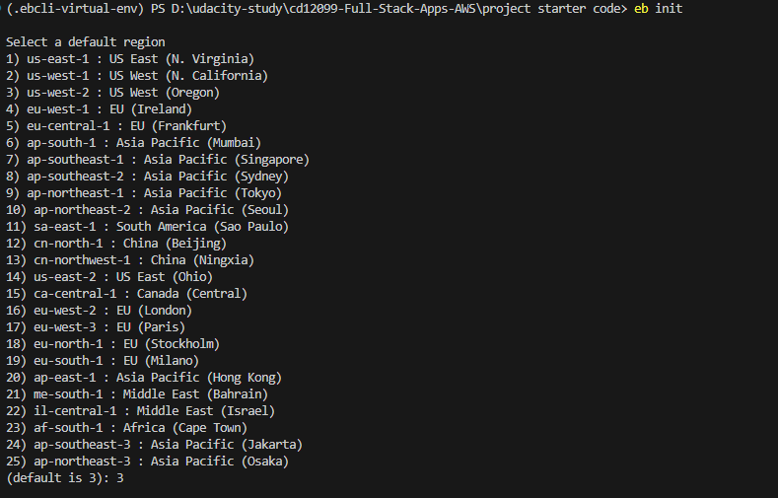

EB create

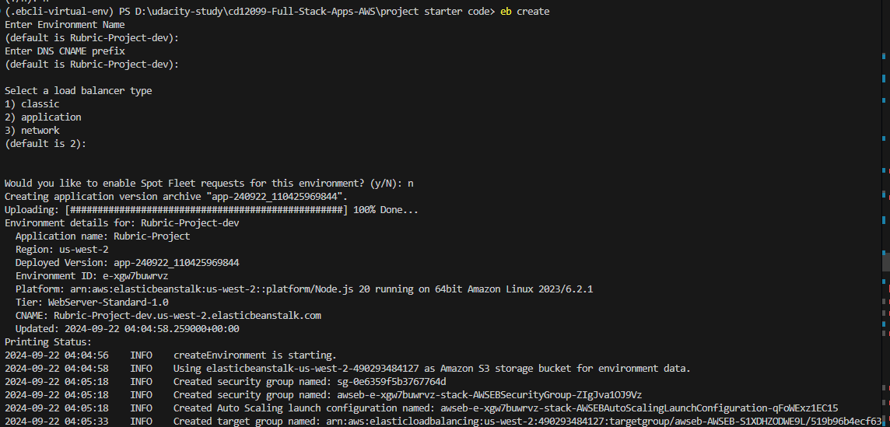

EB deploy

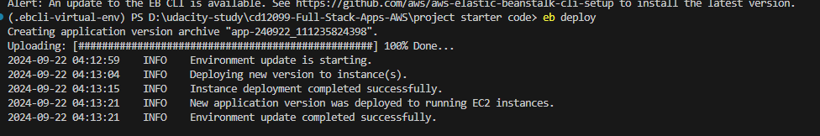

EB environments

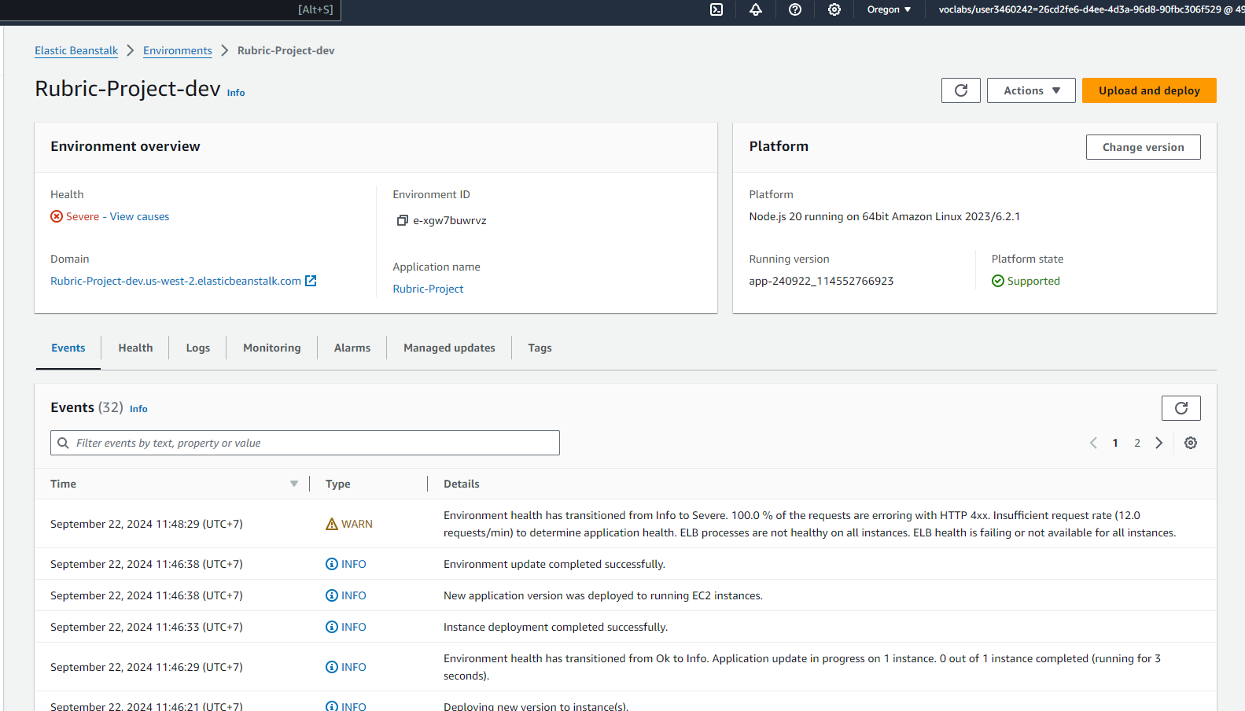

1. Testing project:  
   